**MOTORISATION**

# Aims

* Reliable engine
* Reduce the impact of the air intake restrictor

# Constraint

According to the rule, all the air used by the engine should go through a 20mm diameter air intake restrictor.

Consequences after the “maximum” engine speed is reached:

* Constant power after a certain engine speed
* Decay of the torque

# Engine choice

Figure 1: Diagram of engine choice

* Choice of the Honda CBR600RR, particularly for is reliability, and impact of the restrictor on this engine.

# Air intake and exhaust

## Objective

* Reduce the impact of the air intake restrictor
* Dispose of a stock of air between the engine and the air intake restrictor
* Low pressure loss in the plenum

## Acoustic study

Hypothesis:

* Intake: 20°C
* Exhaust: 600°C

Lengths:

* Admission runner: 351mm
* Exhaust:
  + First runner: 402-426mm
  + Collector: 296-308mm
  + Final collector: 378mm
* Gain of torque in the constant power zone.

# Engine tuning

Sensors:

* Camshaft angle
* Crankshaft speed
* Water temperature
* Air temperature

Parameters:

* Fuel injection time
* Ignition timing: timing advance

Objective: increase torque and efficiency

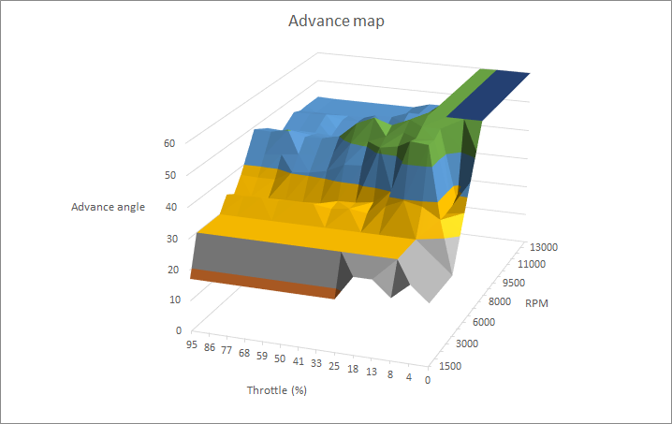

Figure 1: 3D timing advance map